.nav-bar a{
color:rgb(255, 255, 255);
text-decoration: none;
}
.nav-bar a:hover{
color:blue;
text-decoration: underline;
}
.nav-bar {
display: flex;
justify-content: row;
gap: 25px;
}

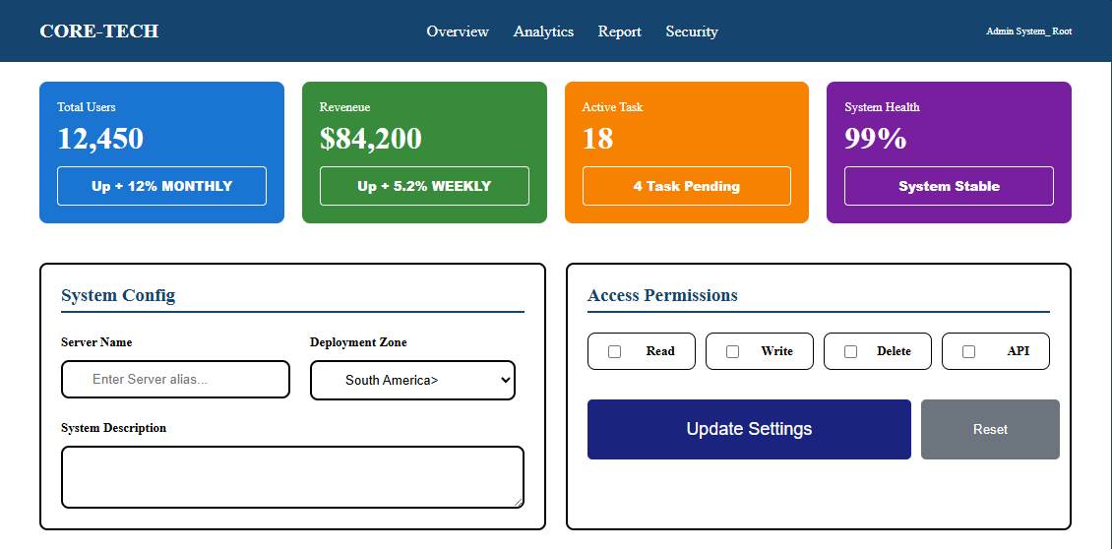
Question1:
.updatebutton{
display: grid;
grid-template-columns: 70% 30%;
gap: 10px;
}
.update{
padding: 20px 40px;
background-color: #1a237e;
color: white;
border-radius: 5px;
border: none;
font-size: large;
}
.reset{
padding: 20px 40px;
background-color: #6c757d;
color: white;
border-radius: 5px;
border: none;
}
.checkboxs{
display: grid;
grid-template-columns: repeat(4, 1fr);
gap: 10px;
margin-bottom: 30px;
}
.checkboxs label{
display: flex;
border: 1px solid black;
border-radius: 8px;
padding: 10px 20px;
align-items: center;
justify-content: space-between;
}
.grid_2{
display:grid;
grid-template-columns: 1fr 1fr;
gap: 20px;
padding: 20px 40px;
}
.big-box{
display: flex;
flex-direction: column;
gap: 10px;
}
.big-box textarea{
border: 2px solid black;
border-radius: 8px;
}
.minibox{
display: grid;
grid-template-columns: 1fr 1fr;
gap: 20px;
}
label{
font-weight: bolder;
font-size: small;
}
.minibox1 input{
display: flex;
padding: 10px 30px;
border: 2px solid black;
border-radius: 8px;
margin-bottom: 20px;
margin-top: 10px;
}
.minibox2 label{
margin-bottom: 10px;
}
.minibox2 select{
display: flex;
padding: 10px 30px;
border: 2px solid black;
border-radius: 8px;
margin-bottom: 20px;
margin-top: 10px;
}
.config{
border: 2px solid black;
border-radius: 8px;
padding:20px;
}
.system{
color:#15456e;
padding-bottom: 5px;
margin-bottom: 20px;
border-bottom: 2px solid #15456e;
}
.boxes{
display: grid;
grid-template-columns: repeat(4, 1fr);
gap: 18px;
padding: 20px 40px;
}
.box1{
border-radius: 8px;
padding: 18px;
background-color: #1975d1;
}
.box2{
border-radius: 8px;
padding: 18px;
background-color: #378b3b;
}
.box3{
border-radius: 8px;
padding: 18px;
background-color: #f78100;
}
.box4{
border-radius: 8px;
padding: 18px;
background-color: #781fa0;
}
.btn {
width: 100%;
padding: 10px 20px;
background-color: transparent;
border: 1px solid white;
color:white;
border-radius: 4px;
font-size: 13px;
font-weight: 800;
}
.p1{
color:white;
margin-bottom: 5px;
font-size: small;
}
.h1{
color:white;
margin-bottom: 10px;
font-weight: 800;
}

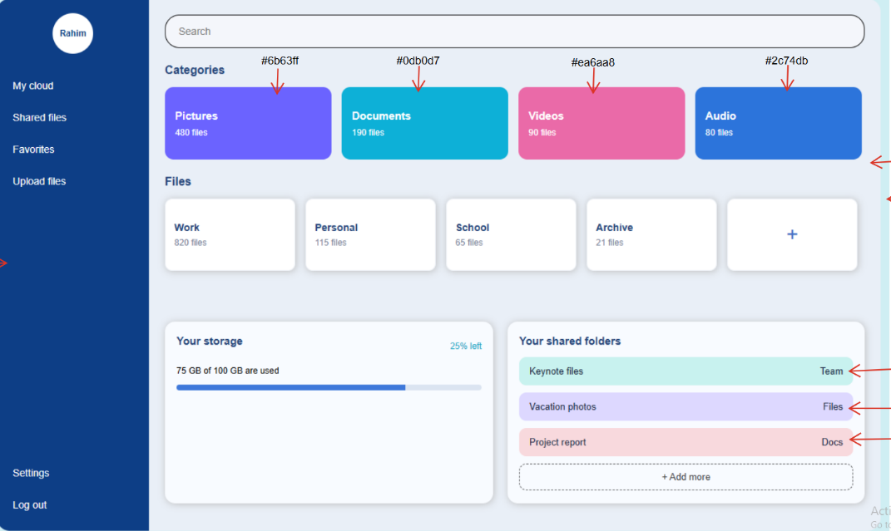
Css part
.percent{
background: #e2e8f5;
height: 8px;
border-radius: 4px;
overflow: hidden;
}
.percent75{
height: 100%; background: #2c74db;
}
.gb{
margin-bottom: 10px;
}
Css part
.minibox1{
padding: 20px 40px;
border-radius: 10px;
box-shadow: 1px 1px 5px gray;

}
Html part
<p class="gb">75 GB of 100 GB is used</p>
<div class="percent">
<div class="percent75" style="width:75%;"></div>
</div>
css.part
profile{
display: flex;
justify-content: center;
margin-bottom: 30px;
}
.roundrahim{
color:#0d3e86;
height: 60px;
width: 60px;
background-color: white;
border-radius: 50%;
margin: 10px;
align-items: center;
display: flex;
justify-content: center;
text-align: center;
}
<div class="profile">
<p class="roundrahim">Rahim</p>
</div>

